**Navigate page**

React native navigation official link

Link : <https://reactnavigation.org/docs/getting-started>

**Step 1**

Install some of the libraries

>>> npm install @react-navigation/native

>>> npm install react-native-screens react-native-safe-area-context

>>> npm install @react-navigation/stack

>>> npm install @react-navigation/native-stack

**Step 2**

Create a folder name **src** inside a root directory

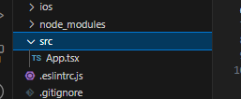

Move App.tsx or App.js inside a **src** folder

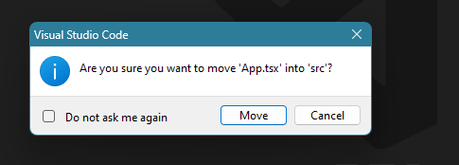

Update Imports App

Open **index.js**

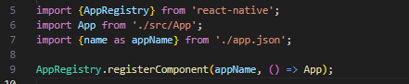

**Step 3**

Create **screens** folderinside a **src** folder

And create your pages

Eg

**Home.jsx**

**Details.jsx**

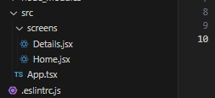

Open **App.tsx** andremove all unwanted stuffs

Import downloaded libraries for **navigations** and Screens

**App.tsx**

import React from 'react';

import type { PropsWithChildren } from 'react';

import { SafeAreaView, ScrollView, StatusBar, StyleSheet, Text, useColorScheme, View, } from 'react-native';

// Navigation

import { NavigationContainer } from '@react-navigation/native';

import { createNativeStackNavigator } from '@react-navigation/native-stack';

// Screens

import Home from './screens/Home';

import Details from './screens/Details';

function App(): JSX.Element {

    return (

    );

}

export default App;

**Step 4**

Define which type of data you want to share with screens

Goto this page   
Link : <https://reactnavigation.org/docs/typescript/#type-checking-screens>

Add this before app

// Navigation

import { NavigationContainer } from '@react-navigation/native';

import { createNativeStackNavigator } from '@react-navigation/native-stack';

// Screens

import Home from './screens/Home';

import Details from './screens/Details';

export type RootStackParamList = {

    Home: undefined;

    Details: { productId: string };

};

const stack = createNativeStackNavigator<RootStackParamList>()

function App(): JSX.Element {

    return (

        <NavigationContainer>

            <stack.Navigator>

                <stack.Screen name="Home" component={Home} />

                <stack.Screen name="Details" component={Details} />

            </stack.Navigator>

        </NavigationContainer>

    );

}

export default App;